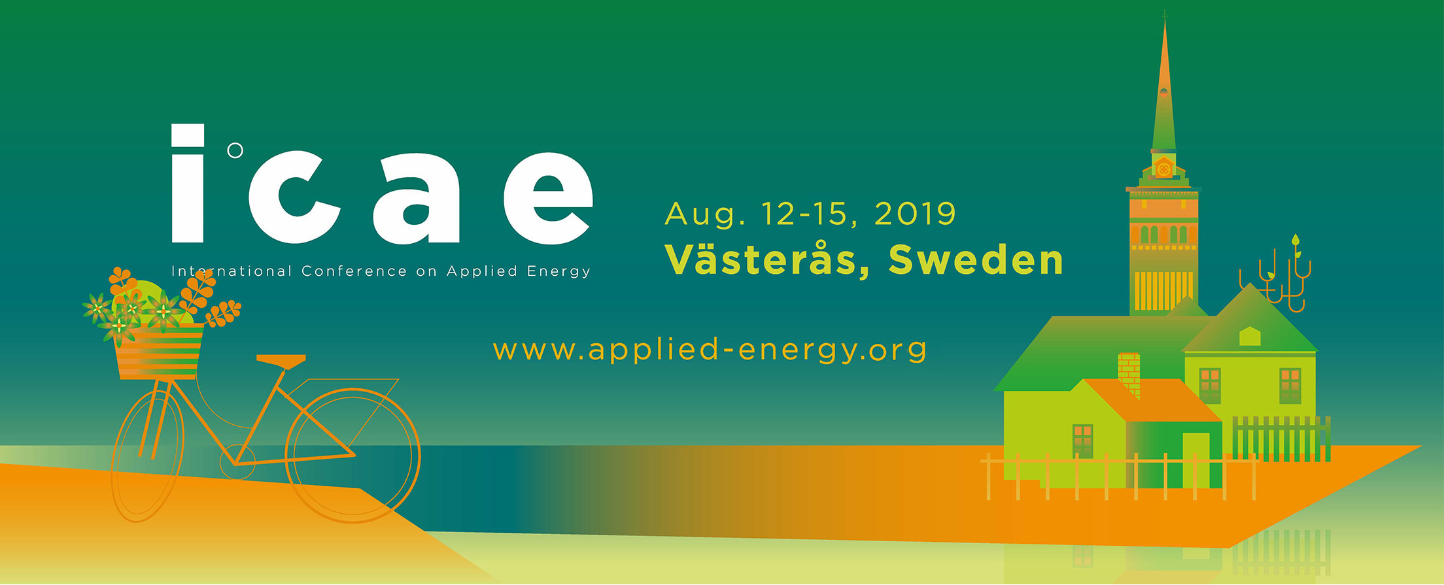
Full Name:
Title:
Affiliation:
Dear Full Name (Birthday:YYYY/MM/DD; Passport number: ***),
Greetings from the Organizing Committee!
On behalf of the Organizing Committee of the 11th International Conference on Applied Energy (ICAE2019), which has been jointly organized by Future Energy Center, Mälardalen University, we are pleased to inform you that your research paper has been accepted for presentation at ICAE2019 (http://www.applied-energy.org) to be held in Västerås, Sweden during Aug 12-15, 2019.
We cordially invite you to present your work at the ICAE2019 conference. We also take this opportunity to invite you to take part in the post-conference activities, including visiting the local utility companies about energy and waste treatment during August 16-17, 2019 to exchange information about advanced energy and sustainable technologies. Additional information about the conference is available at the conference website: http://www.applied-energy.org.
Looking forward to your kind participation.
Sincerely

Prof Erik Dahlquist Prof. Jinyue Yan
Chairman of the 11th International Conference on Applied Energy (ICAE2019)

